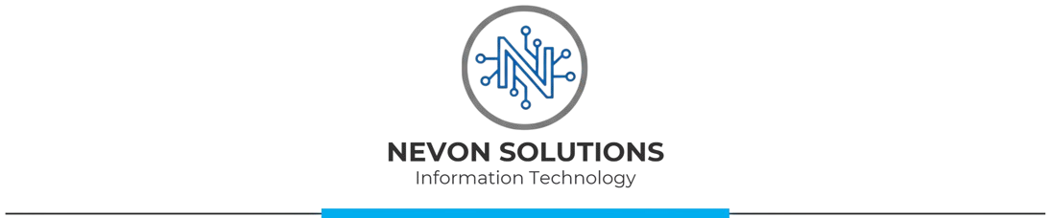

CHANGE REQUEST FORM
Biometric Student Attendance System
NS-SRS-2026-001
CR Number | CR-___ | Date Submitted | DD/MM/YYYY
Project Name | Biometric Student Attendance System
SRS Version | 0.8
Submitted By | Name | Role | e.g., Director of Operations
Contact | Email / Phone
Priority | □ High □ Medium □ Low

Section 1: Change Request Details
Requirement ID | e.g., NFR-SEC-01
Current Wording
Proposed Modification
Reason for Change
Expected Business Value

Section 2: Impact Assessment (Nevon Solutions — within 5 working days)
Technical Feasibility | □ Feasible □ Not Feasible □ Feasible with Conditions
Feasibility Comments
Schedule Impact | Estimated delay (days/weeks)
Budget Impact | Estimated additional cost
Dependent Requirements | List affected requirement IDs
Risk Level | □ High □ Medium □ Low
Assessed By | Name, Date

Change Request Form for Biometric Student Attendance System | 

Section 3: CCB Decision
Decision | □ Approved □ Rejected □ Deferred
Conditions / Comments
Schedule Extension | Agreed extension (if any)
Contract Amendment Required | □ Yes □ No

 | BioSec Representative | Nevon Solutions Representative
Name
Signature
Date

Section 4: Implementation Tracking
SRS Section(s) Updated | List section numbers
iRTM Updated | □ Yes □ No □ N/A
Implementation Date | DD/MM/YYYY
Verified By | Name, Date
This form is governed by the High-Risk Change Control Process defined in Section 8.3 of NS-SRS-2026-001.
Change requests are valid only for requirements that already exist in the SRS.

